**Project Report**

**1.INTRODUCTION**

* 1. **overview**

Start with a brief, engaging introduction that captures the essence of your restaurant in a sentence or two.

**Cuisine:**

Describe the type of cuisine your restaurant offers, whether it's Italian, Chinese, American, fusion, etc.

Highlight any specialties or signature dishes that set your restaurant apart.

**Atmosphere:**

Discuss the ambiance and style of your restaurant. Is it cozy and romantic, casual and family-friendly, or elegant and upscale?

Mention any unique decor or design features that enhance the dining experience.

**Location:**

Provide the address and any notable landmarks or proximity to popular attractions.

Include information about parking options and public transportation access if applicable**.**

**1.2Purpose**

High Quality & Quantity with Affordable Price

**2.Problem Definition & Design Thinking**

**2.1 Empathy map**

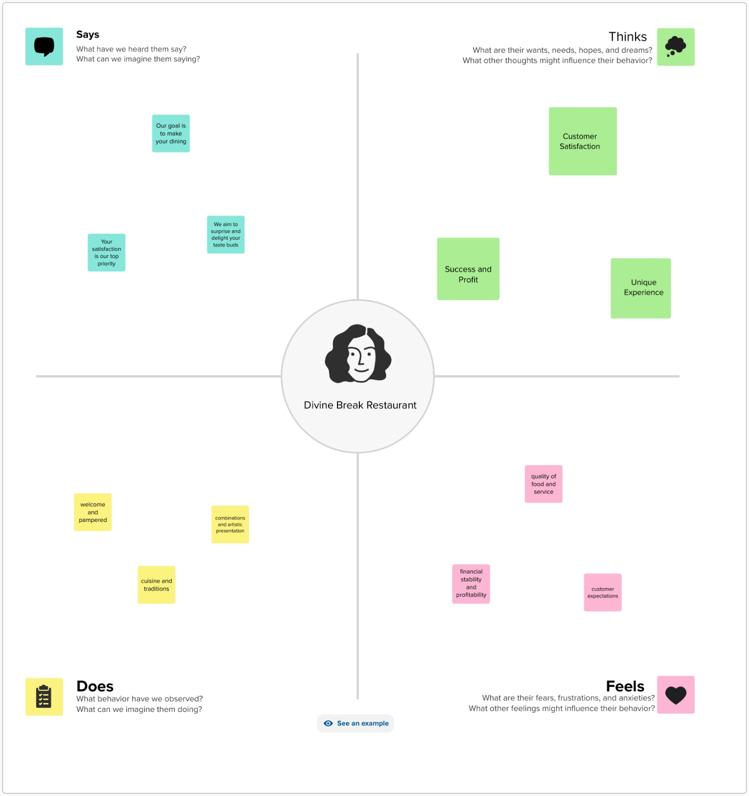

**2.2 Ideation & brainstorming map**

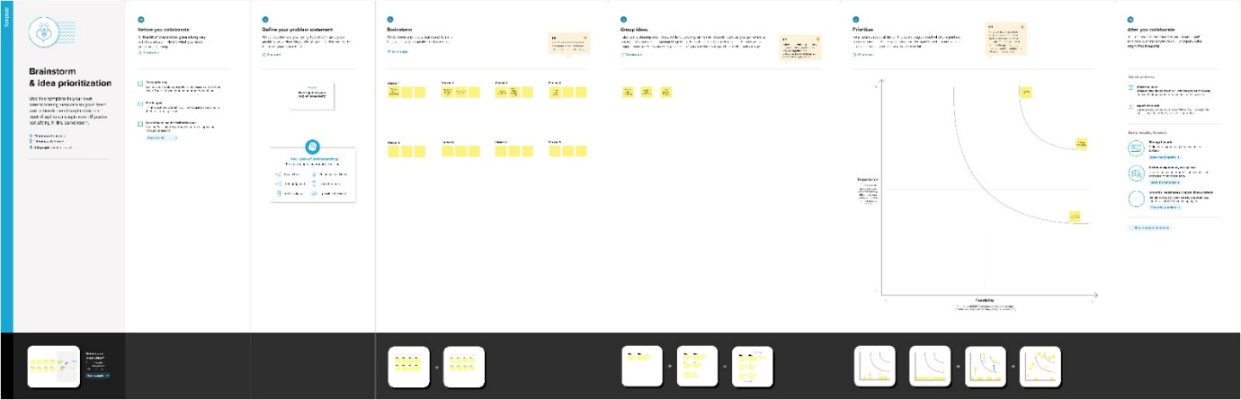

**Result :**

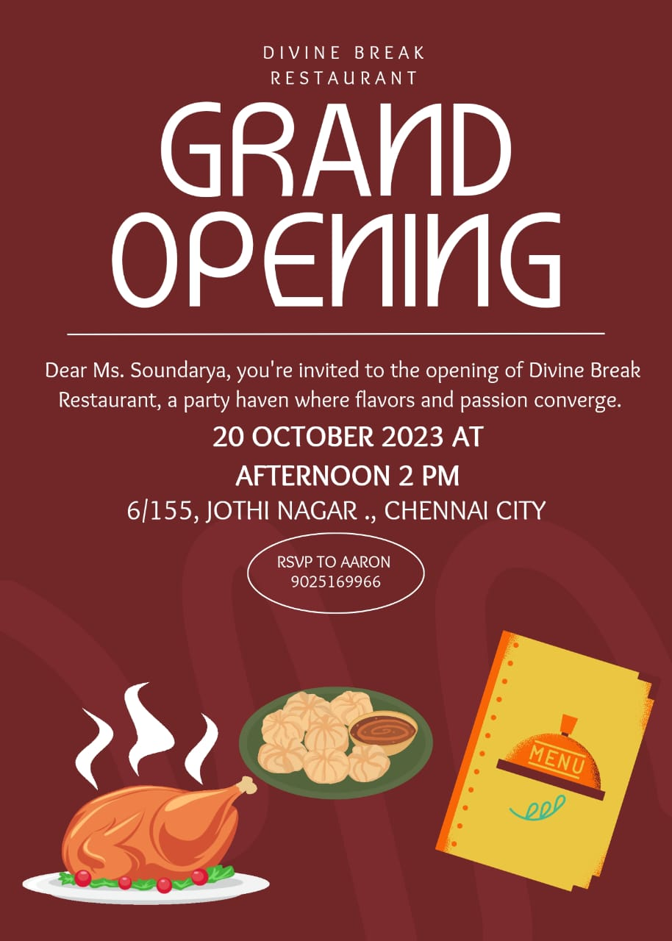

**4.Advantages & Disadvantages**

**Advantage:**

1.Event Hosting

2. Brand Loyalty

3. Passion and Creativity

**Disadvantage:**

1. Intense Competition

2. Economic Factors

**5.Application**

1. Hotel Management

2.Cafeteria

3.Office

**6.Conclusion**

Writing a compelling conclusion for a restaurant involves summarizing key points and leaving a lasting impression. Your conclusion should make readers or potential customers feel excited and eager to visit or learn more about your restaurant.